**Seeing the Big Picture**

Understand how your role fits with and supports organisational objectives. Recognise the wider Civil Service priorities and ensure work is in the national interest.

## Who do you work for and What does the company do?

I work for the ministry of defence (MOD), they job is to protect the people of the UK from external threats, such as states outside the NATO alliance (like Russia, China, and North Korea, etc.), also from terrorist threats, and finally to establish peace and give back human rights to mistreated civilians living under a brutal violent dictatorship such as in Iraq by overthrowing the government.

As well as physical threats, the MOD also deal with cyber threats. Within the MOD I work in a section called ISS or Information System Services, the job of ISS is to protect against cyber threats mainly and also manage the maintenance of the MOD Network (MODNet). This is done my creating contracts with external company’s called MSP’s.

**Changing and Improving**

Seek out opportunities to create effective change and suggest innovative ideas for improvement. Review ways of working, including seeking and providing feedback.

## what are your goals and visions

my work goal is to one day work for a big tech company doing programming. I enjoy programming a lot, and a job like this would be of a huge interest to me

**Making Effective Decisions**

Use evidence and knowledge to support accurate, expert decisions and advice. Carefully consider alternative options, implications and risks of decisions.

Here is an example of where I made an effective decision: A user told me their computer was running very slow, so I turned the computer on it took several minutes to boot and almost all programs crashed when I tried to open it, once it finally booted into the operating system desktop. After a lot of patience, I eventually managed to open task manager and saw some strange executable files running on the computer I had never seen before, I could see from the resource monitor part of task manager this programs using almost 100% CPU, hogging RAM, and was sending lots of data over the internet. I tried to close the program using end task, the program would not close not matter how many tied I tried to close it. I even went into the command line and even tried using “taskkill /f /im” but I got an error back saying “access denied”. I was running on an administrator user account how did I not have access to close this program hogging all the resources? Anyway I shut down the computer, and booted into safe mode. From there I started windows in safe mode with internet disable command line interface only. I then attempt to run an anti-virus scan using the users anti-virus software. The anti-virus detected the program as a threat and quarantined it.

I then booted the computer back into windows normally, and the computer seemed to work well, it was not slow anymore. It turns out that programs was a virus that I had just removed, booting into safe mode and running an anti-virus scan was the solution to the problem and allowed me to remove that malicious program.

So that’s an example of me problem solving, trying to close the program through the command line, looking at the program’s system resource usage in tasks manager, and finally removing the program by booting into safe mode and running an anti-virus scan.

**Leadership**

Show pride and passion for public service. Create and engage others in delivering a shared vision. Value difference, diversity and inclusion, ensuring fairness and opportunity for all.

**Communicating and Influencing**

Communicate purpose and direction with clarity, integrity and enthusiasm. Respect the needs, responses and opinions of others.

Face to face

An example of face to face communication would be organising a 1v1 meeting with another work colleague, below is an example of me having a meeting with Lynne to discuss the OSM project work.

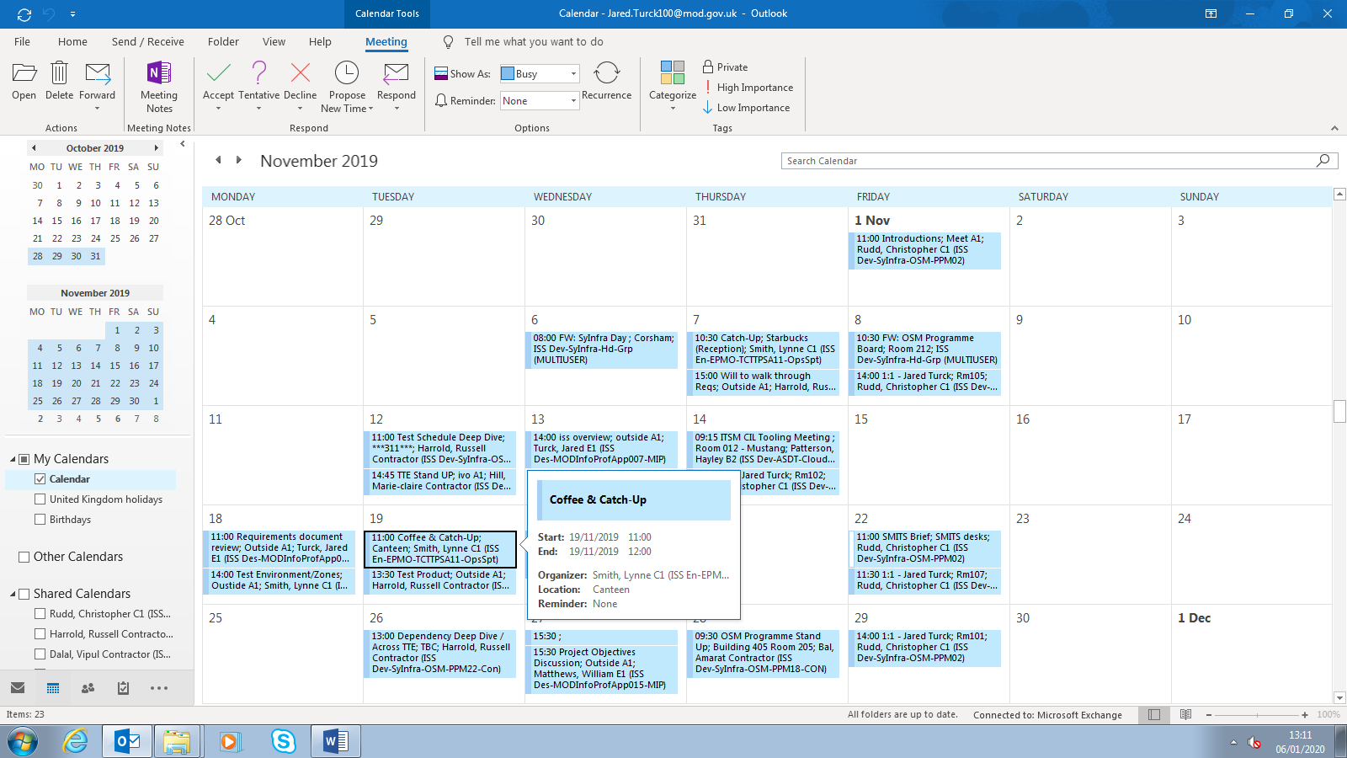

Oral

An example of oral communication is in meetings, I have meetings regularly where the whole team discuss the work they have been doing and we all can contribute to the conversation. The screenshot below shows a meeting in my calendar

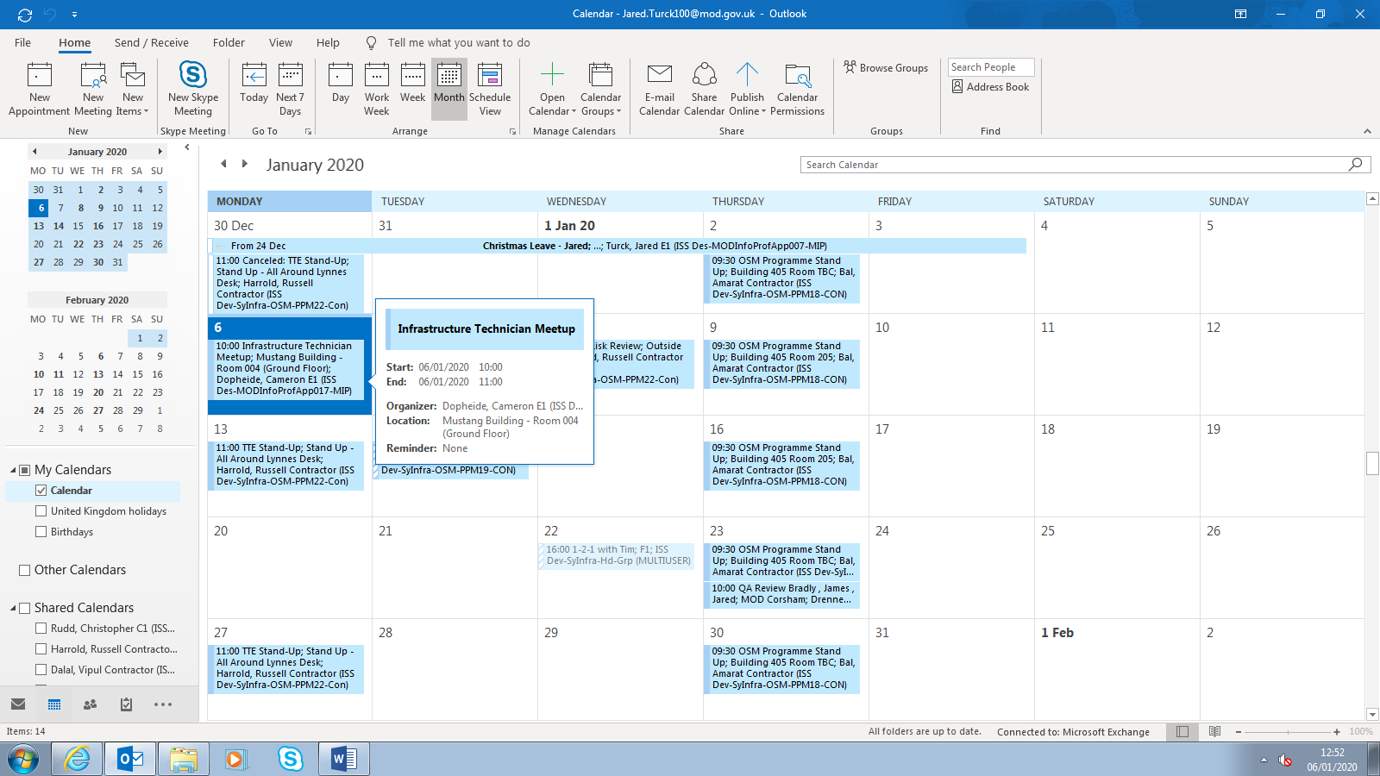

Remote

TeamViewer can be used to access a computer remotely and support a user, I have used TeamViewer countless times to fix an IT problem on a user’s computer. The screenshot below shows a user being asked if they want to allow, to take control of their computer.

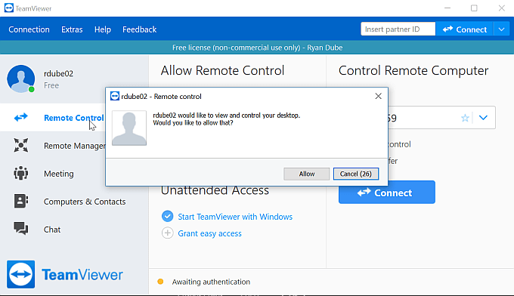

The screenshot above shows the TeamViewer client software.

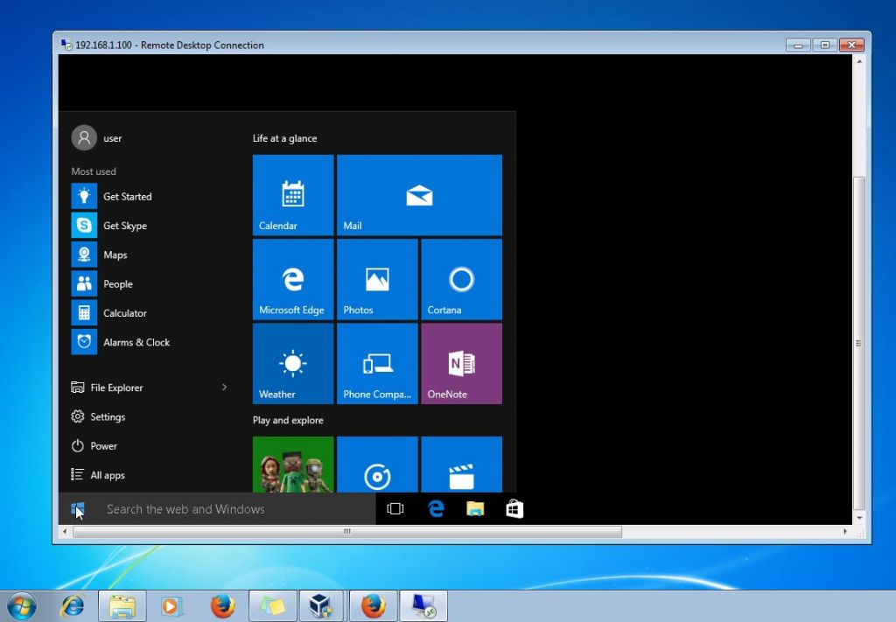

The screenshot above shows me connecting to a remote computer using TeamViewer and controlling their keyboard/mouse. Here you can see me opening the windows 10 start menu on a MOD clients personal computer, to help with a problem they where having where they could not access there emails.

## Which method do you prefer and which method is beneficial to the business.

I prefer instant message, it allows me to talk to anyone at any time, I don’t have to try organise a meeting and find a time where we are both free, instead I can just send them a message, they receive it and reply as soon as they are free or can do. IM is great for quick conversations. But for detailed conversations or if you have a large amount to say, a meeting is better as you can talk a lot faster orally instead of typing.

**Working Together**

Form effective partnerships and relationships with people both internally and externally, from a range of diverse backgrounds, sharing information, resources and support.

The screenshot below shows me giving support to another user through instant message, I designed an resource distribution system for him.

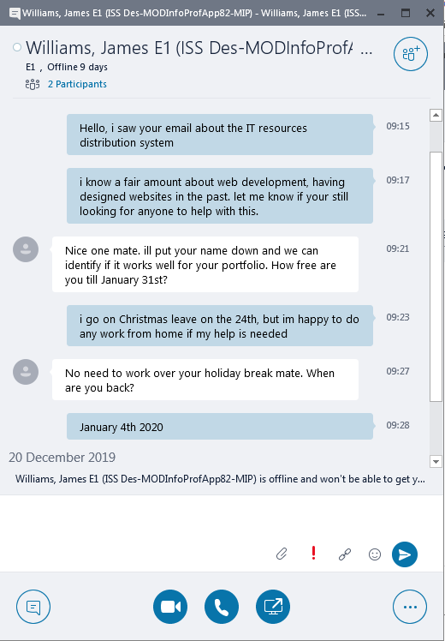

We are working together, as I am helping with design a resource management system.

**Developing Self and Others**

Focus on continuous learning and development for self, others and the organisation as a whole.

**Managing a Quality Service**

Deliver service objectives with professional excellence, expertise and efficiency, taking account of diverse customer needs.

**Delivering at Pace**

Take responsibility for delivering timely and quality results with focus and drive.